**T.C.  
DOKUZ EYLUL UNIVERSITY  
FACULTY OF ENGINEERING**at, metin içeren bir resim

Açıklama otomatik olarak oluşturuldumetin, logo, daire, grafik içeren bir resim

Açıklama otomatik olarak oluşturuldu

**CME 3204 Data Communications and Computer Networks**

**Metropolitan Area Network Simulation**

**by**  
  
  
**2020510059-EREN KÖTÜĞ  
2020510003-HASAN METE AKDENİZ**

**May 2024**

grafik, ekran görüntüsü, yazı tipi, logo içeren bir resim

Açıklama otomatik olarak oluşturuldu

**TABLE OF CONTENT**

**Introduction 3**

1.1. Project Definition and Problem Formulation 3

1.2. The purpose and motivation of the project 4

1.3. Term Definitions 4

1.4. Related Work 5

**Method and Simulation 6**

2.1. Simulation and Modeling Concepts 6

2.2. Simulation Environment/Tool 6

2.3. Network Design Requirements 7

2.4. Requirement Analysis 7

2.5. Definitions of the System/Model 7

2.6. Simulation Elements 16

**Traffic Analysis and Simulation Results 17**

Scenario 1: 18

Scenario 2: 22

Scenario 3: 25

Scenario 4: 28

Scenario 5: 31

Scenario 6: 34

Scenario 8: 38

Scenario 9: 41

**Conclusion 43**

**References 44**

# **CHAPTER ONE**

# **Introduction**

## **Project Definition**

Computer Network planning and design is an iterative process, including topological design, network architectures, and network traffic characterization. Well-designed computer network architecture should support maximum number of network users, traffic load with minimum delay, and adequate hardware support for network expansions. However, the designer should keep the balance between the cost of network hardware and the system requirements.

The project involves designing a Metropolitan Area Network (MAN) using Cisco Packet Tracer software. The MAN will connect two distinct branches of an office in a city, which will be connected by routers over an Internet Service Provider (ISP). The connection technologies between the ISP and the branches should also be considered in the design.

The first branch of the network will have three facilities with different units and requirements. The first facility has 3 workstation (PC) users, 3 wireless users (laptop) and 3 smartphoneusers. All of the users in this facility have the ability to browse web, send e-mails andtransfer files by using their devices. The second facility has 6 workstation users who are able to use Web and FTP. 2 of workstations are used for VoIP conference events. The third facility has a server farm including 10 Web servers, 4 FTP servers, 1 DHCP server, 1 mail server and 1 domain name server (DNS).

The second branch of the network will also have three facilities with different units and requirements. The first facility has 5 workstation users, 5 wireless users and 5 tablet users, who are able to connect to the Internet using wireless connection, browse Web and use e-mailapplications. The second facility has 5 workstation users and 2 smartphone users. They have the ability to browse the web, edit applications and transfer files. The third facility has 5 workstations and 2 mobile devices that are used to browse Web, send and receive emails.

To design the MAN network, we need to consider the network topology, network architecture, and network traffic characteristics. The topology will define the physical layout of the network, while the architecture will define the logical structure of the network.

In conclusion, designing a Metropolitan Area Network (MAN) that meets the requirements of the organization is a complex process that requires careful planning and consideration of various factors such as topology, architecture, and network traffic characteristics. The network design should be able to support maximum network users and handle high traffic loads with minimum delay while keeping the cost of the network hardware and system requirements in mind.

**1.2. The Purpose and Motivation of the Project**

The aim of this project is to design and construct a Metropolitan Area Network (MAN) that meets the specified network requirements and specifications. The MAN is planned to connect two different branches through routers via an Internet Service Provider (ISP). The first branch will consist of three different facilities, each with different units and requirements. Similarly, the second branch will also have three different facilities with different units and requirements. The primary objective is to build a network that can support the maximum number of users between these two points while minimizing and managing traffic effectively. This is aimed at ensuring the efficient and reliable operation of the network. The project intends to establish the fundamental infrastructure for data and communication flow between different locations within the city.

One of the advantages of the project is that it enhances collaboration among students and staff by establishing a robust communication network between different campuses. Additionally, this project allows students and staff to improve their technology skills and gain knowledge about modern networking technologies.

However, the project faces some challenges. Particularly, it can be costly and may lead to unexpected delays or technical difficulties. Moreover, large-scale network infrastructures may pose security risks and require regular maintenance and support. Nevertheless, when these challenges are addressed properly, the project can strengthen the university's technological capabilities and provide students with a better educational experience.

* 1. **Term Definitions**

**Network:** A network is a group of interconnected devices, such as computers, printers, and servers, that can communicate and share resources.

**Metropolitan Area Network (MAN):** A MAN is a type of network that spans a geographical area larger than a LAN (Local Area Network) but smaller than a WAN (Wide Area Network), typically covering a city or metropolitan area.

**Router:** A router is a networking device that connects multiple networks together and directs traffic between them.

**ISP (Internet Service Provider):** An ISP is a company that provides internet access to customers.

**Workstation:** A workstation is a computer that is optimized for high-performance, typically used for tasks such as video editing or computer-aided design.

**Wireless user:** A wireless user is a user who connects to the network using wireless technologies such as Wi-Fi.

**Smartphone:** A smartphone is a mobile phone that has advanced computing capabilities and can connect to the internet.

**Web server:** A web server is a computer that stores and delivers web pages to clients over the internet.

**FTP (File Transfer Protocol) server:** An FTP server is a computer that stores and delivers files using the FTP protocol.

**DHCP (Dynamic Host Configuration Protocol) server:** A DHCP server is a computer that automatically assigns IP addresses to devices on a network.

**Mail server:** A mail server is a computer that handles email communication, storing and forwarding messages between clients.

**DNS (Domain Name System) server:** A DNS server is a computer that translates human-readable domain names into IP addresses.

**Wireless connection:** A wireless connection is a network connection that uses wireless technologies such as Wi-Fi to transmit data.

**VoIP (Voice over Internet Protocol) conference:** A VoIP conference is a type of audio conference that uses the internet to transmit audio data.

**Packet:** A packet is a unit of data that is transmitted over a network. It contains both the data being transmitted and information about the destination address and other network routing information.

**Channel:** A channel is a pathway through which data is transmitted on a network.

**Protocol:** A protocol is a set of rules and standards that govern how data is transmitted over a network.

**System:** A system refers to a collection of hardware, software, and network components that work together to perform a specific task.

**Network architecture:** Network architecture refers to the design and layout of a computer network, including the devices, connections, and protocols used to transmit data.

**Router:** A device that connects multiple networks together and directs traffic between them.

**Switch:** A device that connects multiple devices within a network and directs traffic between them.

**Access point:** A device that allows wireless devices to connect to a wired network.

**Firewall:** A security device that monitors and controls incoming and outgoing network traffic based on predefined security rules.

**DHCP server:** A server that assigns IP addresses to devices on a network automatically.

**DNS server:** A server that translates domain names into IP addresses.

**VoIP:** Voice over Internet Protocol, a technology that allows voice communication over a network.

**FTP:** File Transfer Protocol, a protocol used for transferring files over a network.

**WAN:** Wide Area Network, a network that spans a large geographic area, such as a city or country.

**LAN:** Local Area Network, a network that connects devices within a small geographic area, such as a building or campus.

## **Related Work**

There are many works that have contributed to the advancement of network modeling/simulation and network design in various domains and applications. Some examples are:

"Network Simulation Experiments Manual" by Emad Aboelela is a comprehensive resource designed for those interested in learning network simulation. It starts with the basic concepts of network simulation and provides step-by-step instructions on how to create and evaluate different network scenarios using various simulation tools. The book is filled with examples and practical approaches, making it a valuable reference for students, researchers, and network professionals looking to enhance their network simulation skills.

"Network Design Cookbook: Architecting Cisco Networks" by CCIE No. 6778, Michel Thomatis serves as a comprehensive resource for Cisco network design. It covers various aspects of planning, configuring, and optimizing networks using Cisco devices. With practical approaches, it provides step-by-step instructions and examples for analyzing different network scenarios. Additionally, it addresses topics such as security, redundancy, and performance optimization, serving as a valuable guide for those seeking in-depth knowledge in network design.

These works modeling/simulation and network design in the context of complex large-scale systems. They also show how different disciplines and technologies can be integrated to enhance the accuracy, efficiency, and usability of network modeling/simulation and network design tools.

# **CHAPTER TWO**

# **Method and Simulation**

## **2.1. Simulation and Modeling Concepts**

The network design process entailed identifying both logical and physical requirements. We adopted a bottom-up approach during the implementation phase, allowing us to start with smaller components and gradually scale up.

For the branch office network infrastructure simulation, we incorporated various user types (workstations, wireless devices, tablets, and smartphones) and equipment (switches, routers, wireless routers, and cables). Utilizing a DHCP server, we allocated IP addresses to users within each facility and scrutinized the connections between workstations and devices.

At the third facility of the initial branch office, we established server farms to facilitate email exchange, web browsing, file sharing, and VoIP services for users. Servers for web hosting, DNS, email, FTP, and DHCP were deployed in the server room, linked to the primary switch of the server farm. This switch, in turn, connected to the server router. Subsequently, the server farm router was interconnected with the primary router of the three facilities in the secondary branch via a serial connection, establishing a Metropolitan Area Network. Post establishment of inter-branch connectivity, we conducted trial runs (via simulations) between workstations to validate network functionality.

## **2.2. Simulation Environment/Tool**

We simulated our design using Cisco Packet Tracer Tool. This tool is designed to simulate various network devices, including routers, switches, wireless access points, servers, and endpoints. Users can drag and drop these devices onto a virtual workspace, creating a network topology that closely resembles a real-world network. The virtual devices in Packet Tracer can be configured and interconnected, allowing for the creation of complex network topologies and the testing and validation of network designs. Cisco Packet Tracer offer a range of advantages and challenges compared to real-world network projects. These tools provide cost-effectiveness as they offer an ideal environment for network design and configuration without the need for real devices. Especially when used for educational purposes, they provide students and network professionals with practical experience in exploring network concepts and technologies. Additionally, they allow for testing and troubleshooting various network scenarios. However, they may not fully simulate real-world conditions and may be insufficient for some complex network scenarios. Nevertheless, simulations are generally an effective tool for reinforcing theoretical knowledge and enhancing network skills.

## **2.3. Network Design Requirements**

The network design of our project meets the requirements specified in the request. The network architecture is based on the server/client model and uses various protocols for device communication, such as HTTP, HTTPS, DHCP, DNS, FTP, POP3, TCP, SSH and SMTP. Network components include five switches, seven routers(four wireless router), seventeen servers, and different user types (workstation, wireless, smartphone, tablet, and phone). The network topology is stars for different LANs within the MAN. Wireless devices connect to WRT300N access points, workstations and servers connect to 2960 switches, and switches and routers connect to each other. We chose the 2811 model for the router connecting F1, F2 and F3 in Branch 1, unlike other routers (Router-PT) for VOIP service. In this way, we have established a reliable and secure Metropolitan Area Network.

## **2.4. Requirement Analysis**

All necessary requirement analysis for the project were made according to the requested situations on . Our requirement analysis is as follows. Metropolitan area network design includes two distinct branches office in a city, which are connected by routers (at least two routers for each branch) over an ISP (Internet Service Provider). First branch’s network is comprised of 3 distinct facilities and each facility has different units and requirements. All specification for the first branch office is as following: First facility has 3 workstation (PC) users, 3 wireless users (laptop) and 3 smartphone users. All of the users in this facility have the ability to browse web, send e-mails and transfer files by using their devices. Second facility has 6 workstation users who are able to use Web and FTP. 2 of workstations are used for VoIP conference events. Third facility has a server farm including 10 Web servers, 4 FTP servers, 1 DHCP server, 1 mail server and 1 domain name server (DNS). Second branch includes 3 distinct facilities and each facility includes different units and requirements. First facility has 5 workstation users, 5 wireless users and 5 tablet users, who are able to connect to the Internet using wireless connection, browse Web and use e-mail applications. Second facility has 5 workstation users and 2 smartphone users. They have the ability to browse the web, edit applications and transfer files. Third facility has 5 workstations and 2 mobile devices that are used to browse Web, send and receive emails.

## **2.5. Definitions of the System/Model**

**Assumptions:**

* The system comprises a collection of interrelated components collaborating to accomplish a shared objective.
* The system is assumed to be intricate and may encompass numerous variables and interactions among the components.
* Each component is presumed to fulfill a specific function or role within the system, and the malfunction or failure of any component could impact the overall system performance.
* The system may feature diverse inputs and outputs, with system performance likely contingent upon the quality and precision of these inputs.

The structure of the system is a network architecture that is designed using a server/client model. It consists of various network components, including switches, routers, access points, servers, and different types of users such as workstations, wireless devices, smartphones, tablets, and IP phones. The network topology is a star, and the system is designed to support different protocols for device communication, such as HTTP, HTTPS, DHCP, DNS, FTP, POP3, TCP, SSH, and SMTP. The system also includes a simulation environment/tool, which is Cisco Packet Tracer, that was used to simulate and validate the network design.

For the project of building a Metropolitan Area Network (MAN), the input parameters have been defined in the project specifications. The network design includes two distinct branches offices in a city, which are connected by routers over an ISP. The first branch's network comprises three facilities, while the second branch includes three facilities as well. Each facility has different units and requirements, including the number of workstation users, wireless users, tablet users, and mobile devices. The different facilities also require specific servers, such as web servers, FTP servers, DHCP servers, mail servers, and DNS servers.

çizgi, diyagram içeren bir resim

Açıklama otomatik olarak oluşturuldu

**General Design of the System**

**metin, diyagram, ekran görüntüsü, çizgi içeren bir resim

Açıklama otomatik olarak oluşturuldu**

**First Branch First Facility**

**metin, ekran görüntüsü, diyagram, çizgi içeren bir resim

Açıklama otomatik olarak oluşturuldu**

**First Branch Second Facility**

**metin, diyagram, ekran görüntüsü, çizgi içeren bir resim

Açıklama otomatik olarak oluşturuldu**

**First Branch Third Facility**

**metin, ekran görüntüsü, çizgi, diyagram içeren bir resim

Açıklama otomatik olarak oluşturuldu**

**Second Branch First Facility**

**diyagram, ekran görüntüsü, çizgi, harita içeren bir resim

Açıklama otomatik olarak oluşturuldu**

**Second Branch Second Facility**

**ekran görüntüsü, diyagram, çizgi, metin içeren bir resim

Açıklama otomatik olarak oluşturuldu**

**Second Branch Third Facility**

**ekran görüntüsü, diyagram, çizgi içeren bir resim

Açıklama otomatik olarak oluşturuldu**

**Physical Design of the System**

**ekran görüntüsü, diyagram, dikdörtgen, mor içeren bir resim

Açıklama otomatik olarak oluşturuldu**

**First Branch**

**ekran görüntüsü, tasarım içeren bir resim

Açıklama otomatik olarak oluşturuldu**

**First Branch First Facility**

**ekran görüntüsü, bina, paralel, tasarım içeren bir resim

Açıklama otomatik olarak oluşturuldu**

**First Branch Second Facility**

**dikdörtgen, pencere içeren bir resim

Açıklama otomatik olarak oluşturuldu**

**First Branch Third Facility – Server Room**

**ekran görüntüsü, diyagram, dikdörtgen, çizgi içeren bir resim

Açıklama otomatik olarak oluşturuldu**

**Second Branch**

**tasarım, dikdörtgen, ekran görüntüsü içeren bir resim

Açıklama otomatik olarak oluşturuldu**

**Second Branch First Facility**

**ekran görüntüsü, bilgisayar, paralel, tasarım içeren bir resim

Açıklama otomatik olarak oluşturuldu**

**Second Branch Second Facility**

**ekran görüntüsü, dikdörtgen, paralel, tasarım içeren bir resim

Açıklama otomatik olarak oluşturuldu**

**Second Branch Third Facility**

## **2.6. Simulation Elements**

**System entities:**

* computer nodes
* servers (Web servers, FTP servers, DHCP server, mail server, domain name server)
* workstation (PC) users
* wireless users (laptop, smartphone, tablet)
* routers
* wireless access points
* mobile devices

**System state variables:**

* status of the channels (either idle or busy)
* status of the servers (available or busy)
* network traffic load
* network congestion
* packet drop rate

**Input variables:**

* arrival rate of packets
* packet size
* packet transmission time
* packet delay time
* service rate of servers
* bandwidth capacity of network links

**Resources**:

* server processing capacity
* server storage capacity
* bandwidth capacity of network links
* number of servers

**Activities and events:**

* server processing
* server storage
* network expansion
* network congestion
* packet transmission
* packet routing
* packet dropping
* packet reception
* packet queuing

# **CHAPTER THREE**

# **Traffic Analysis and Simulation Results**

## **Scenario 1:**

A wireless user from first facility of second branch wants to read emails and browse Web.

The process of reading emails involved communication between the user of PC1 and the mail server, following a network path that included B2F1_PC1, B2F1-WIRELESS_ROUTER, B2F1_SWITCH, B2_MAIN_ROUTER_,B1-MAIN_ROUTER1, ISP_ROUTER and EMAIL.

Similarly, to browse the web, communication was established between the user of PC_1 and the web server, following a network path that included B2F1_PC1, B2F1-WIRELESS_ROUTER, B2F1_SWITCH, B2_MAIN_ROUTER_,B1-MAIN_ROUTER1, ISP_ROUTER and WEB1. This network path was also repeated multiple times to complete the scenario.

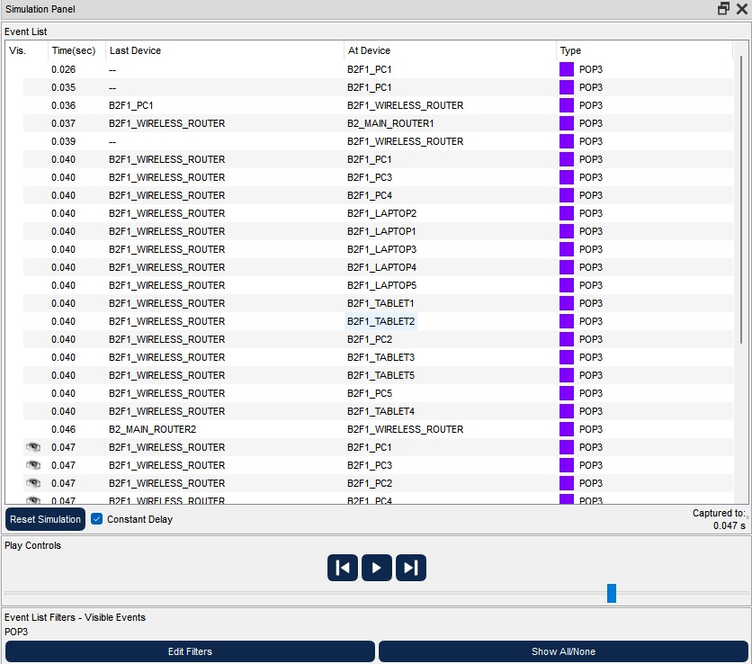

**Event List of Scenario-1 for Read E-Mail**

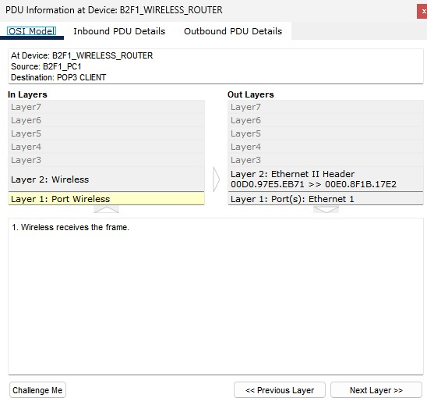

**OSI Model of Scenario-1 for Read E-Mail**

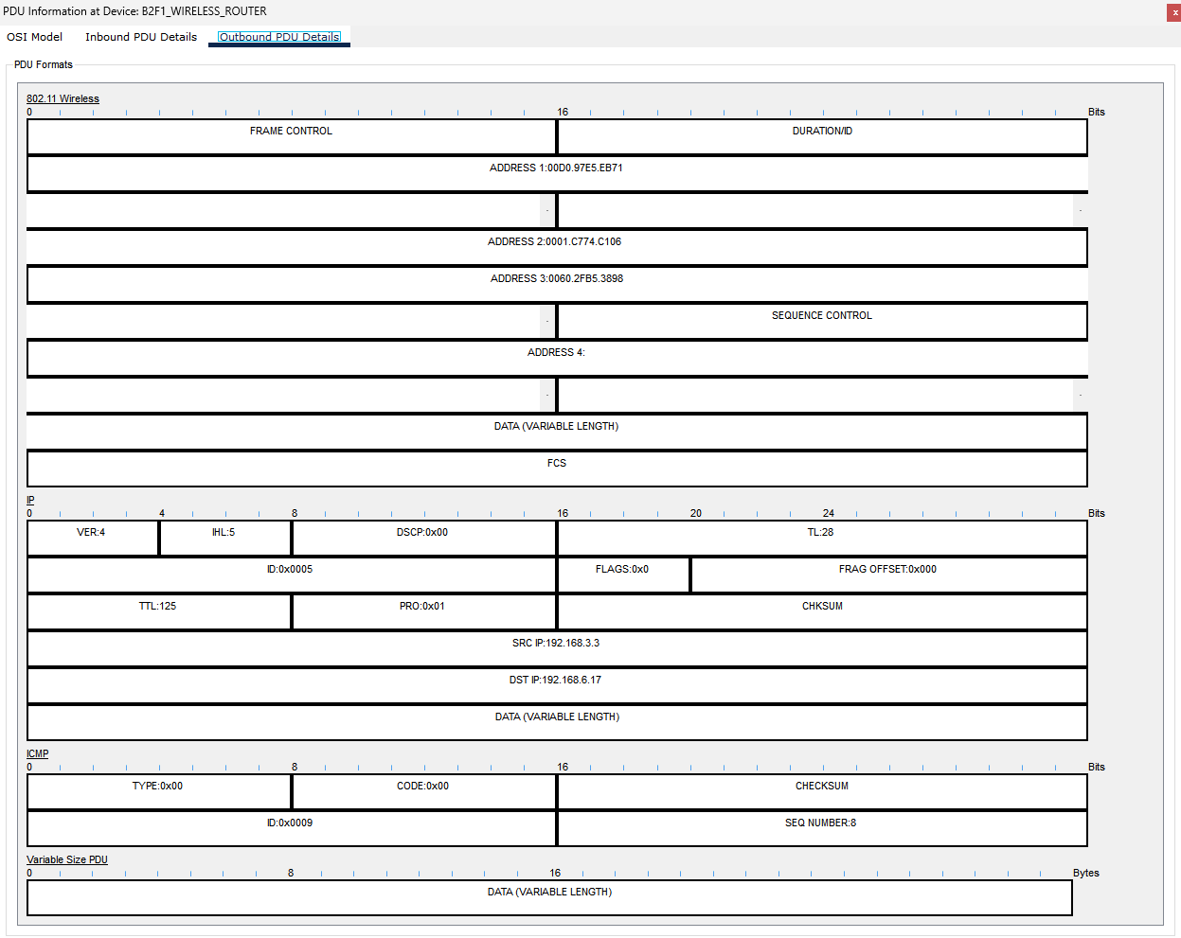

**PDU Output of Scenario-1 for read E-Mail**

**metin, elektronik donanım, ekran görüntüsü, ekran, görüntüleme içeren bir resim

Açıklama otomatik olarak oluşturuldu**

**Result of Scenario-1 for Read E-Mail**

**metin, ekran görüntüsü, yazılım, sayı, numara içeren bir resim

Açıklama otomatik olarak oluşturuldu**

**Event List of Scenario-1 for Browse Web**

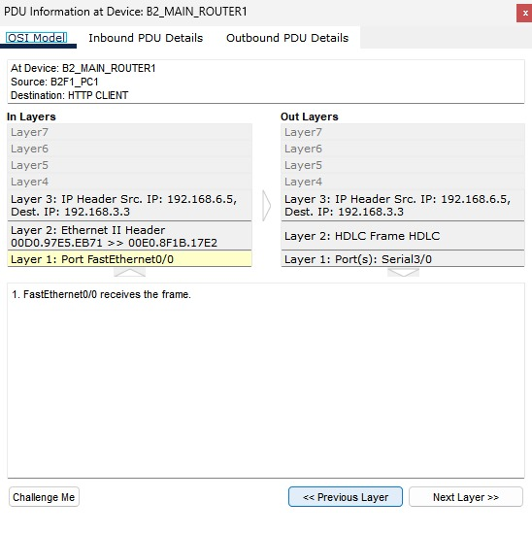

**OSI Model of Scenario-1 for Browse Meb**

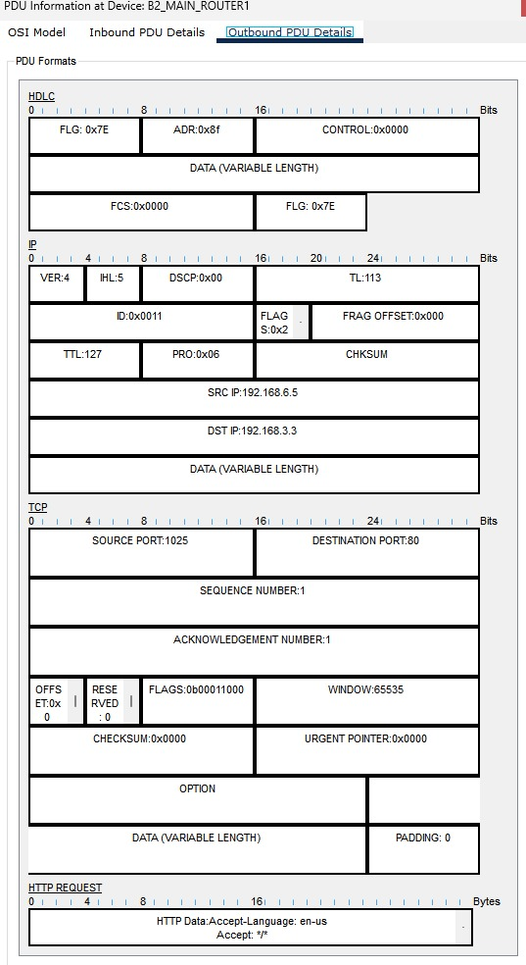

**PDU Output of Scenario-1 Browse Meb**

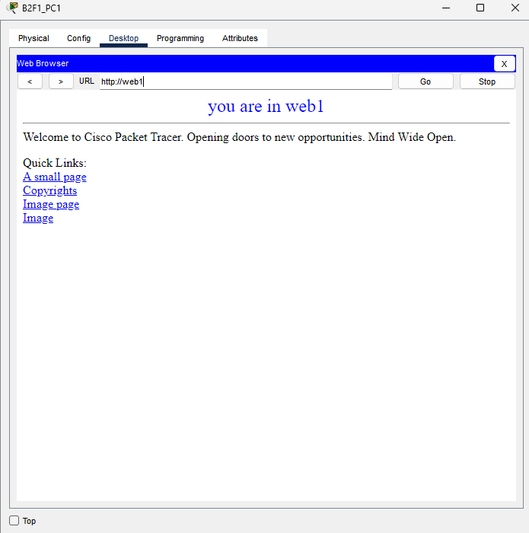

**Result of Scenario-1 for Browse Web**

**Scenario 2:**

A computer engineer from second facility of second branch developed a web application and wants to send his/her code files to FTP server in the third facility of first branch.

A network connection was established between the PC1 user and the FTP server. To send files to the FTP server, the network path followed included B2F2_PC1, B2F2_SWITCH, B2-MAIN_ROUTER1, B2F1_SWITCH,B1_MAIN_ROUTER1, B1_MAIN_ROUTER_, ISP_ROUTER and finally, the FTP server of the PC1 user. This network path was traversed multiple times until the file transfer process was completed.

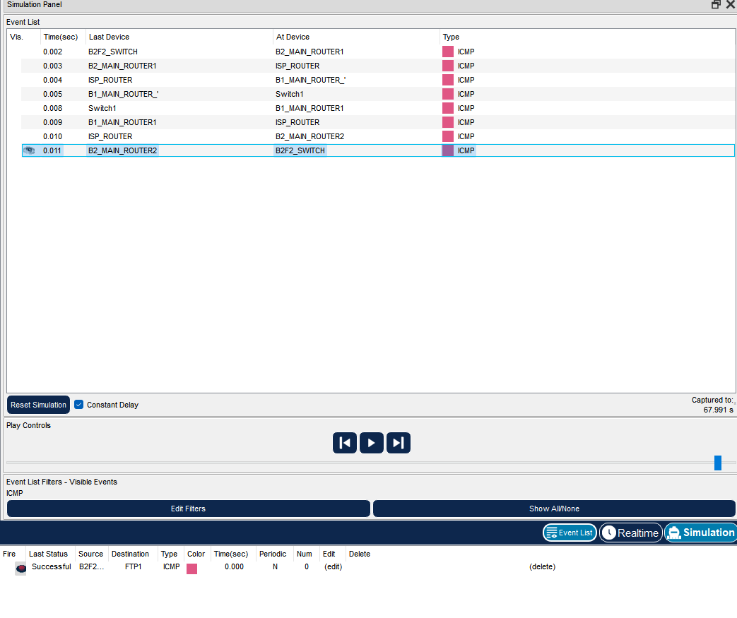

**Event List of Scenario-2**

**metin, elektronik donanım, ekran görüntüsü, ekran, görüntüleme içeren bir resim

Açıklama otomatik olarak oluşturuldu**

**OSI Model of Scenario-2**

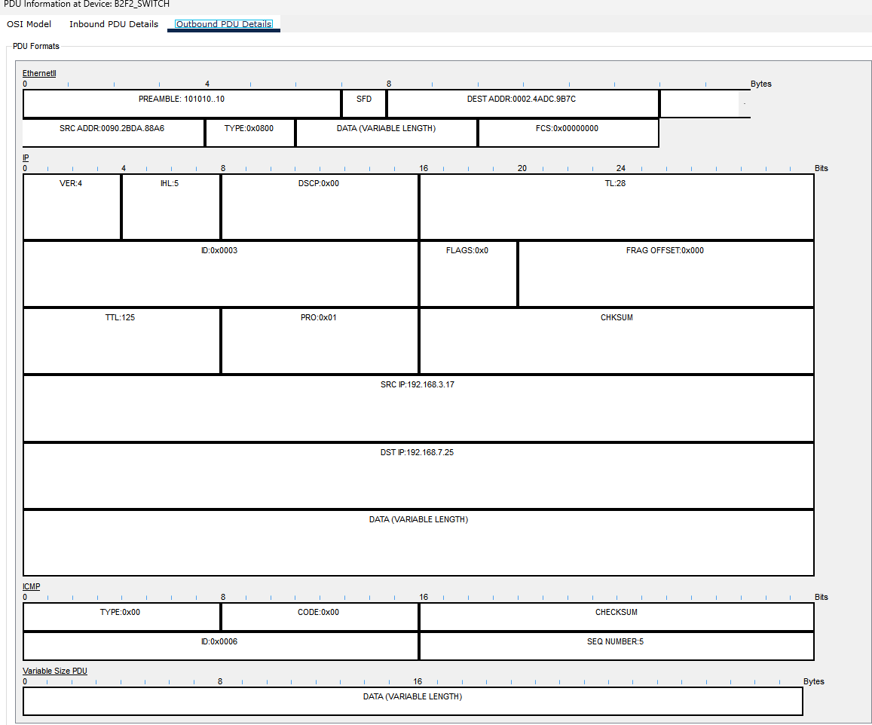

**PDU Output of Scenario-2**

**metin, ekran görüntüsü, yazılım, ekran, görüntüleme içeren bir resim

Açıklama otomatik olarak oluşturuldu**

**Result of Scenario-2.1**

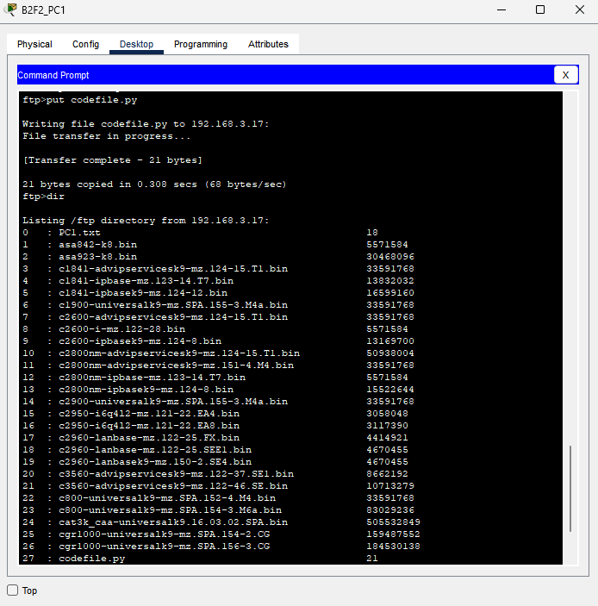

**Result of Scenario-2.2**

**Scenario 3:**

Two users from second facility of first branch want to talk via VoIP.

An IP Phone conference was conducted between B1F2_Phone1 user and B1F2_Phone2 user. The network path followed for this scenario included B1F2_SWITCH, B1_MAIN_ROUTER1. This network path was repeated twice for IP Phones, including B1_MAIN_ROUTER1, IP Phone(0), and IP Phone(1), to complete the conference.

**metin, elektronik donanım, telefon, elektronik cihaz içeren bir resim

Açıklama otomatik olarak oluşturuldu**

**Result of Scenario-3**

**metin, ekran görüntüsü, yazılım, bilgisayar simgesi içeren bir resim

Açıklama otomatik olarak oluşturuldu**

**Event List of Scenario-3**

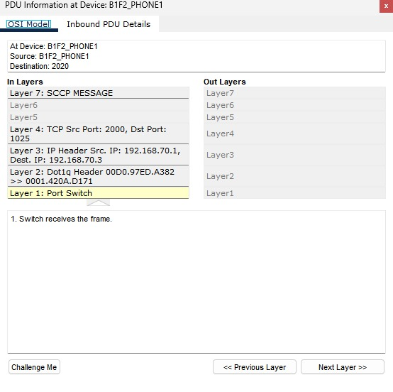

**OSI Model of Scenario-3**

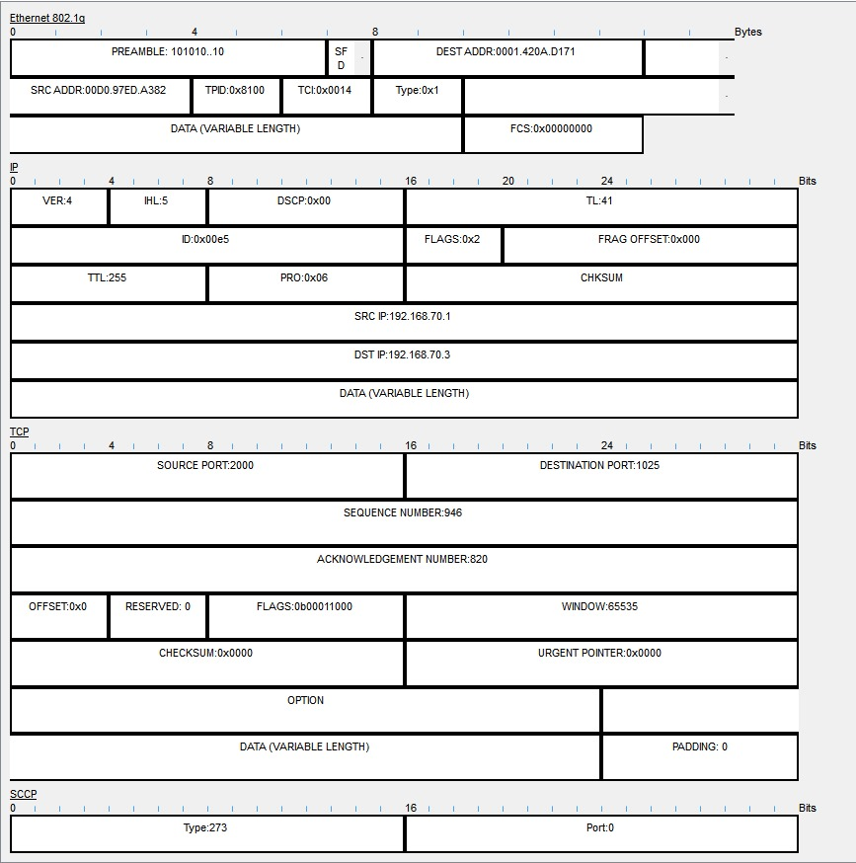

**PDU Output of Scenario-3**

**Scenario 4:**

A user at the second facility of the first branch wants to send an e-mail message to his friend at the second facility of the second branch. Since there was no restriction in the documentation, we decided that it could be used and enabled it to send an e-mail. The process of reading emails involved communication between the user of PC1 and the mail server, following a network path that included B1F2_PC1, B2F2_SWITCH, B2_MAIN_ROUTER1,B1-MAIN_ROUTER1, ISP_ROUTER and EMAIL.

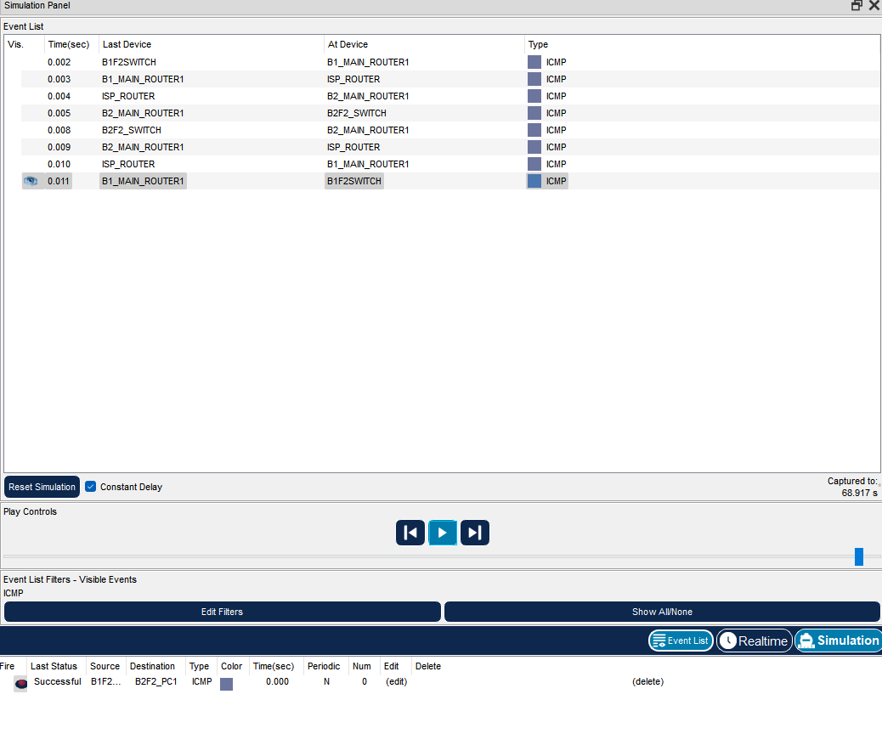

**Event List of Scenario-4**

metin, elektronik donanım, ekran görüntüsü, yazılım içeren bir resim

Açıklama otomatik olarak oluşturuldu

**OSI Model of Scenario-4**

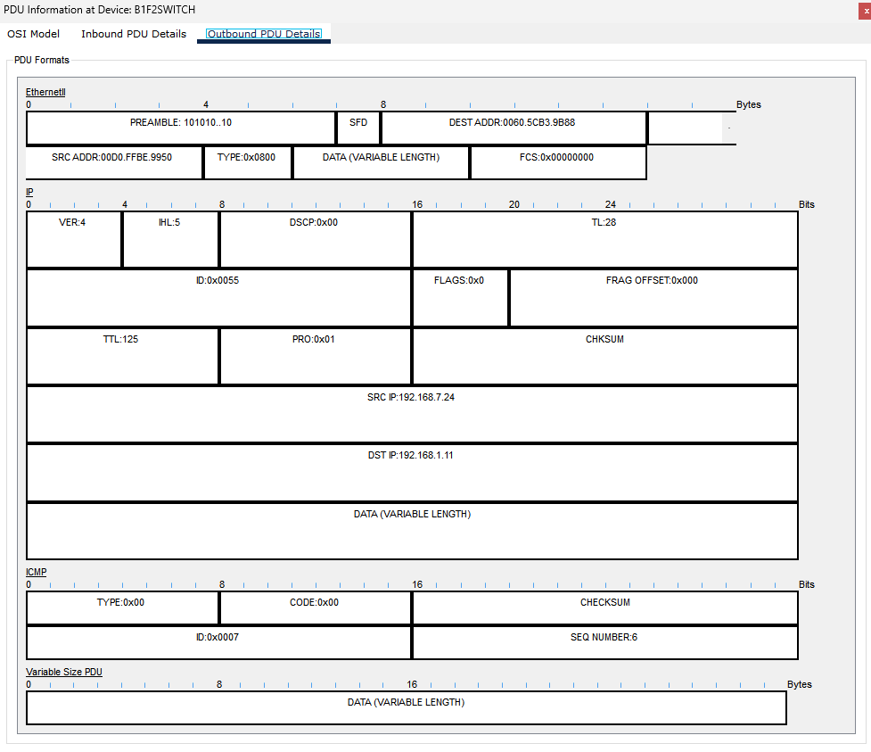

**PDU Output of Scenario-4**

metin, ekran görüntüsü, ekran, görüntüleme, yazılım içeren bir resim

Açıklama otomatik olarak oluşturuldu

**Result of Scenario-4.1**

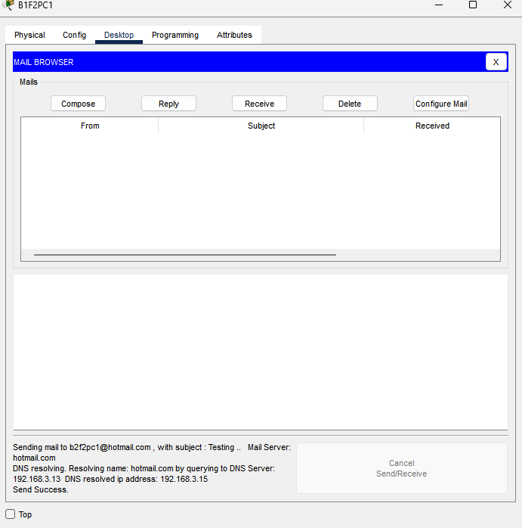

**Result of Scenario-4.2**

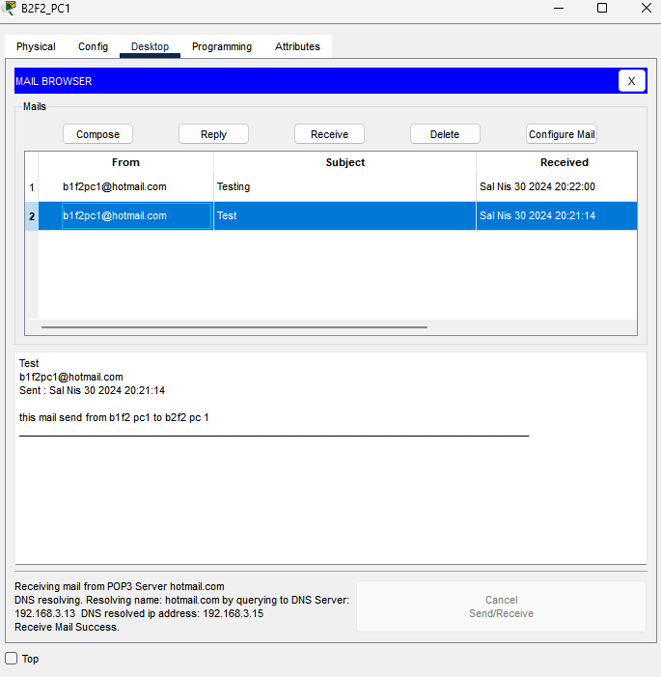

**Result of Scenario-4.3**

**Scenario 5:**

A user from first facility of second branch pings Web server of second facility of first branch.

A ping was initiated between the B2F1_LAPTOP4 user and the web server, following the network path of B2F1_WIRELESS_ROUTER, B2_MAIN_ROUER1, ISP_ROUTER, B1_MAIN_ROUTER_,B1F3_SWTICH,B1_MAIN_ROUTER1 and WEB1.

metin, ekran görüntüsü, yazılım, ekran, görüntüleme içeren bir resim

Açıklama otomatik olarak oluşturuldu

**Event List of Scenario-5**

metin, elektronik donanım, ekran görüntüsü, ekran, görüntüleme içeren bir resim

Açıklama otomatik olarak oluşturuldu

**OSI Model of Scenario-5**

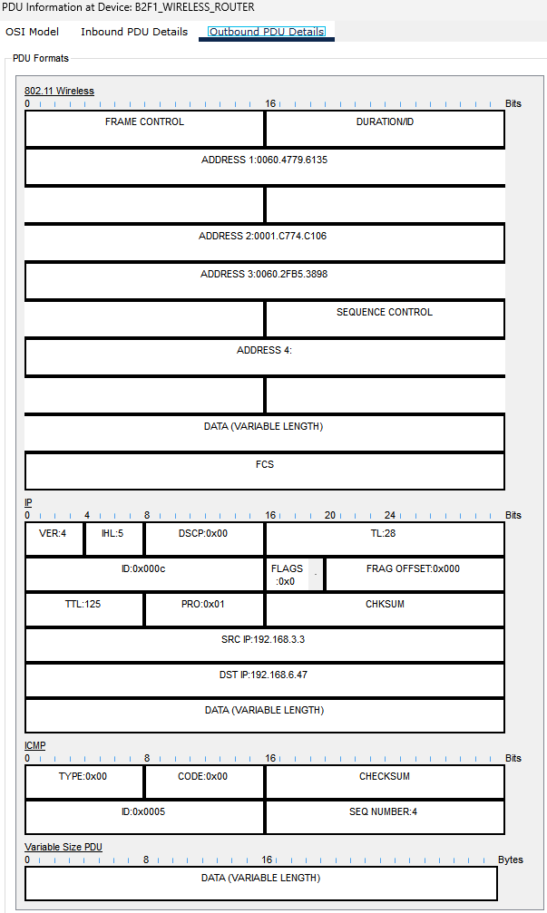

**PDU Output of Scenario-5**

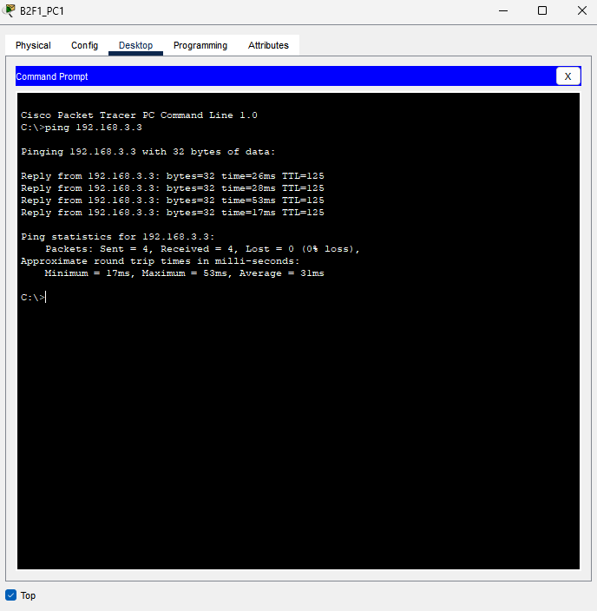

**Result of Scenario-5**

**Scenario 6:**

A laptop user from first facility of first branch office wants to send email to her friend in the first facility of second branch office.

When “B1F1_LAPTOP1” in the first facility of the first branch sends an email to “LaptopB1F1@hotmail.com” in the first facility of the second branch, the email goes through multiple routers and switches. The Wireless Router for Laptop and Smartphones and B1F1_SWITCH in Workstations cluster are the first to receive the email.

The email then proceeds to the B1-ServerRouter and onto the B1_F3(SERVERS) cluster, where it reaches the Server Switch inside. The server user’s name and domain name are determined, after which the mail is sent to the Mail Server.

Using the IP address of the recipient, the email locates the B2F1_SWITCH within the cluster of the first facility of the second branch. Finally, the email reaches the computer of the intended recipient, named which is B2F1_PC5.

Throughout this process of sending the email, various protocols such as DHCP, DTP, STP, TCP, and SMTP play a role.

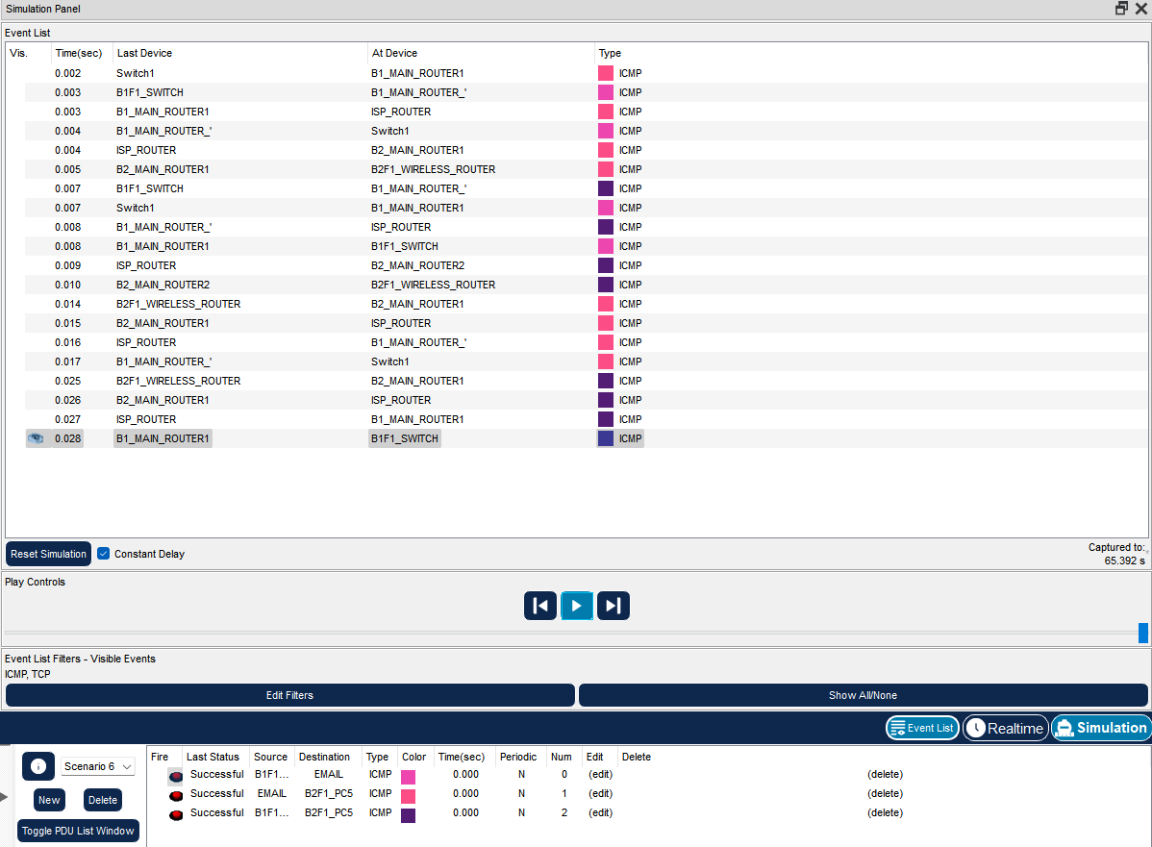

**Event List of Scenario-6**

metin, elektronik donanım, ekran görüntüsü, ekran, görüntüleme içeren bir resim

Açıklama otomatik olarak oluşturuldu

**OSI Model of Scenario-6**

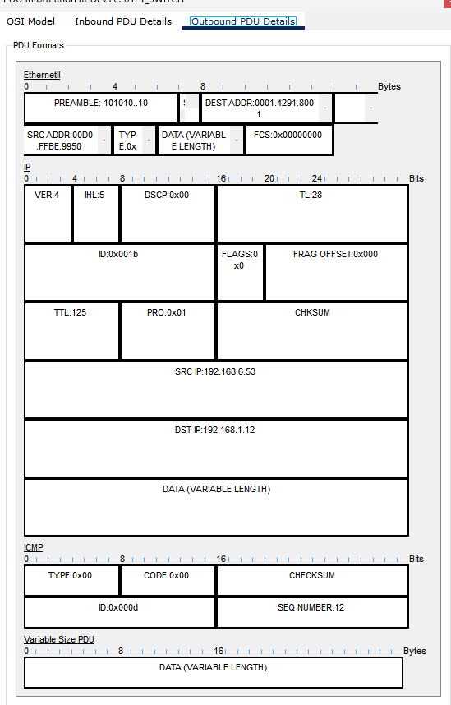

**PDU Output of Scenario-6**

metin, ekran görüntüsü, ekran, görüntüleme, yazılım içeren bir resim

Açıklama otomatik olarak oluşturuldu

**Result of Scenario-6.1**

metin, elektronik donanım, ekran görüntüsü, ekran, görüntüleme içeren bir resim

Açıklama otomatik olarak oluşturuldu

**Result of Scenario-6.2**

**Scenario 8:**

A user at the third facility of the second branch wants to send an e-mail message to his friend at the first facility of the first branch.

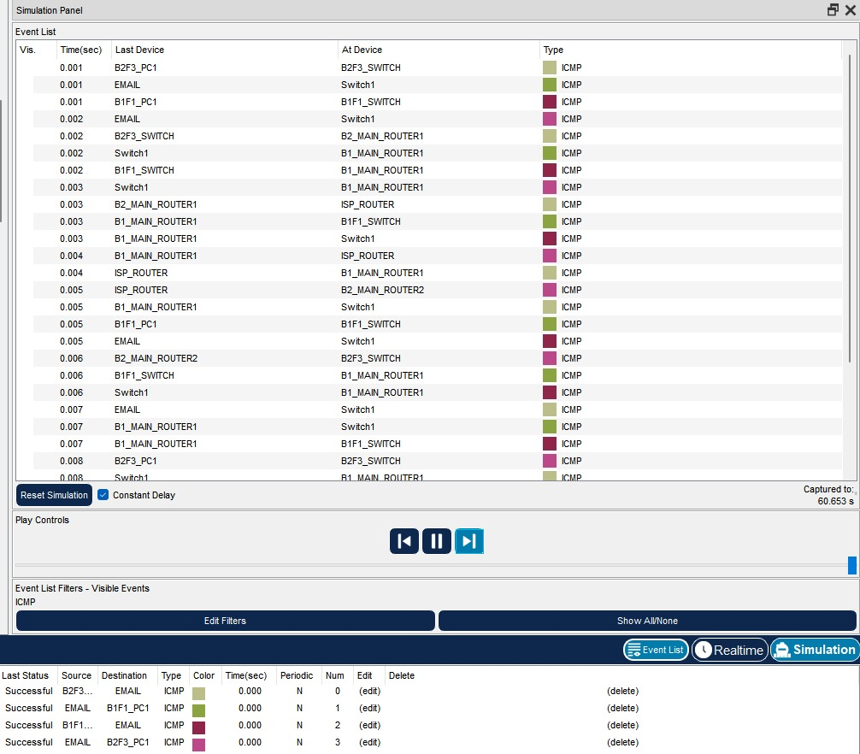

**Event List of Scenario-8**

metin, ekran görüntüsü, yazılım, sayı, numara içeren bir resim

Açıklama otomatik olarak oluşturuldu

**OSI Model of Scenario-8**

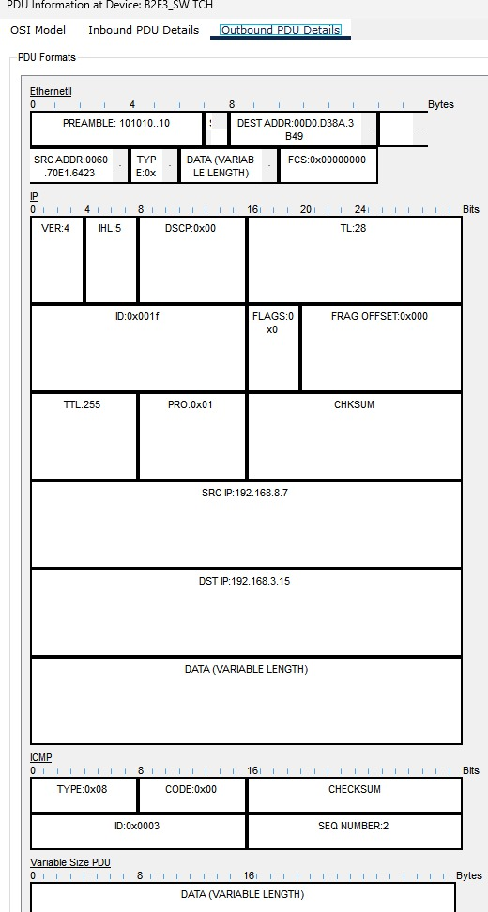

**PDU Output of Scenario-8**

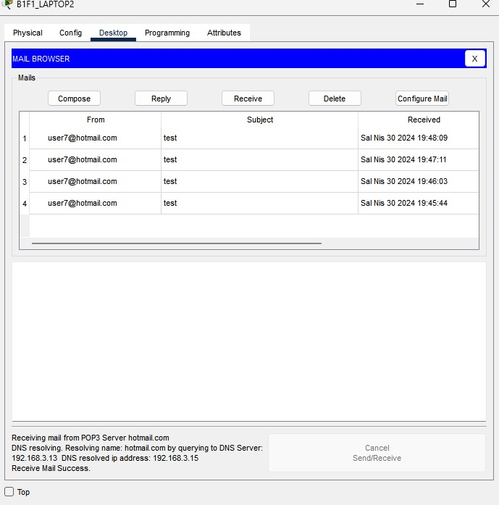

**Result of Scenario-8**

**Scenario 9:**

A user from first facility of second branch pings DNS server of third facility of first branch.

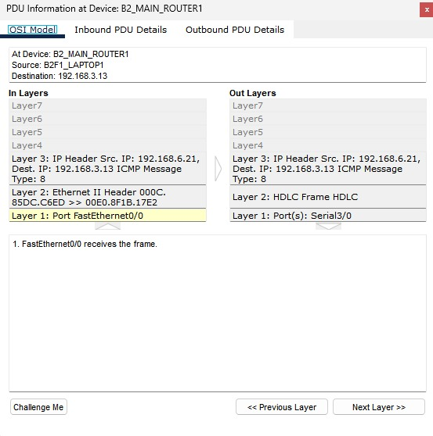

**OSI Model of Scenario-9**

metin, ekran görüntüsü, yazılım, ekran, görüntüleme içeren bir resim

Açıklama otomatik olarak oluşturuldu

**Event List of Scenario-9**

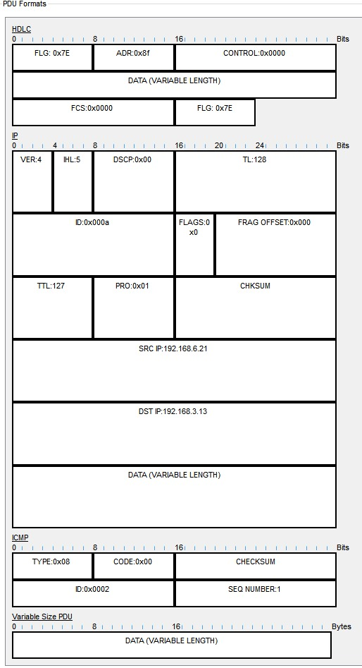

**PDU Output of Scenario-9**

# **CHAPTER FOUR**

# **Conclusion**

In this project, we have designed a Metropolitan Area Network (MAN) by using Cisco Packet Tracer software. The network consists of two branches, each comprising of three facilities with different units and requirements. The first branch has 3 workstation users, 3 wireless users, and 3 smartphones users in the first facility, 6 workstation users with 2 of them used for VoIP conference events in the second facility, and a server farm including 10 Web servers, 4 FTP servers, 1 DHCP server, 1 mail server, and 1 domain name server (DNS) in the third facility. The second branch includes 5 workstation users, 5 wireless users and 5 tablet users ,5 workstation users and 2 smartphone users and 5 workstations and 2 mobile devices in each facility respectively. Our design includes at least two routers for each branch and connection technologies between ISP and branches to meet the network requirements and specifications. Through this project, we successfully implemented a well-designed computer network architecture that supports the maximum number of network users, traffic load with minimum delay, and adequate hardware support for network expansions while keeping the balance between the cost of network hardware and the system requirements.

# **CHAPTER FIVE**

# **References**

[1] DHCP - Configuring the Cisco IOS DHCP Server [Support] - Cisco Systems: https://www.cisco.com/en/US/docs/ios/12_4t/ip_addr/configuration/guide/htdhcpsv.html#wp1143732

[2] Cisco Router DHCP Yapılandırma: https://www.firatboyan.com/cisco-router-uzerinde-dhcp-ayarlari-yapilandirma.aspx

[3] DHCP DNS and Web Server configuration in cisco packet tracer : https://www.youtube.com/watch?v=NmMzIH0alV8&t

[4] FTP Server Cisco Packet Tracer:https://www.youtube.com/watch?v=MPTrbFzIn0Y

[5] Email Server Configuration in Cisco Packet Tracer | Cisco Packet Tracer Email Server || Mail Server : https://www.youtube.com/watch?v=kVVZ1JAbOoI&t

[6] Subnet Mask Nedir ? : https://www.youtube.com/watch?v=FTWfCY-I7MY

[7] Subnet Mask - Explained : <https://www.youtube.com/watch?v=s_Ntt6eTn94>

[8] How to configure VoIp: https://www.youtube.com/watch?v=hiv3WsHEYnk

[9] Configuring DHHCP using Cisco : https://www.youtube.com/watch?v=GCaR8e-16bs

[10] Differences between RIPV1 and RIPV2 :<https://www.youtube.com/watch?v=1eRdMidWd0Y&t=444s>

[12]Wireless router configuration : https://www.youtube.com/watch?v=VD8siw72gkI&t=297s